Formula overview

# 1.power

Power is simply force times velocity, where 1 HP (horsepower, English units) is equal to 0.7457 kW (kilowatt, metric) and 1kW = 1000 Newtons*meters/second.

$$P=F×V$$

P=power (W).

F=force (N).

V=velocity (m/s).

1.Effective Horsepower (EHP): This power is used to overcome a boat’s total resistance. At a given speed, not include the power which is used to turn propellers or other machinery. This power is close to the power of towing a boat.

2. Indicated Horsepower (IHP): This means that the power of driving a boat at given speed, so it includes the power to turn propellers and overcome any additional friction inherent in the system. Generally, the ratio of EHP/IHP is about 1:2.

3. Brake Horsepower (BHP): This is the maximum power that motor can provide in the ratio RPM (rotation speed unit: revolutions per minute). The value of this power is determined by motor manufacturer.

4. Shaft Horsepower (SHP) is the power delivered along the shaft to the propeller at a given RPM. (Techet, 2016)

We need to identify the type of power and make sure the input power and out put power to calculate the power loss percentage. In the solar boar propulsion system, the range rational input power is form 0 to BHP and the output power can be defined as IHP or SHP (In the case of we don’t concern the propeller).

# 2.Torque

If we want to propel the boat by using the power provided by the motor, we need to install rotation shaft and propeller between motor and water. SHP (Shaft horsepower) is converted to a rotary force (or moment) applied to the propeller.

$$T=F×L$$

T=torque (Nm).

F=force (N).

L=length (m).

$$P=F×V=F×L×ω$$

$ω$ =angular velocity (rad/s).

$$P=T×ω$$

As you can see, in the same situation which means same power and same propeller, a slower turning propeller generates more torque.

# 3.Propeller

## 3.1 Open water experiment

The experiment of propeller alone in uniform water flow is called open water experiment.

The open water experiment is to measure the characteristics of the propeller during operation, including the thrust coefficient, torque coefficient and open water efficiency. (Dalian Maritime University).

3.2 Thrust coefiicient

$$K_{T}=\frac{T}{ρ×n^{2}×D^{4}}$$

T=thrust (N).

$ρ$ = liquid density (${Kg}/{m^{3}}$).

n= rotating speed (rpm).

D= diameter (m). (yuguoPei)

3.3 Torque coefficient

$$K_{Q}=\frac{Q}{ρ×n^{2}×D^{5}}$$

Q=torque (Nm). (yuguoPei)

3.4 Open water efficiency

$$η_{0}=\frac{J_{p}}{2π}×\frac{K_{T}}{K_{Q}}$$

$J_{p}$*=* advance ratio.

## 3.5 Advance ratio

If the propeller is working in a rigid interlayer, it is like a screw moving in a nut towel. Undoubtedly, the distance traveled on the axis for one revolution will be equal to the geometric pitch P. But the propeller works behind the boat, and the distance it advances depends on the boat speed. The distance that the propeller advances in the axial direction for one revolution is called the process, expressed in $h_{p}$. The process $h_{p}$ will be less than the geometric pitch P, and the difference (P- $h_{p}$) is called slippage. Because of slippage that thrust is generated. The ratio of slippage to thread pitch is called slippage ratio, expressed by S.

$$S=1-\frac{h_{p}}{P}$$

The ratio of the process $h_{p}$ to the diameter D of the propeller is called the advance ratio. Since the distance the propeller advances per second is n ${*h}_{p}$ = $V_{p}$, the advance ratio can be written as:

$$J=\frac{V_{p}}{n×D}$$

$V_{p}$ = the freestream fluid velocity, typically the [true airspeed](https://en.wikipedia.org/wiki/True_airspeed) of the aircraft or the water speed of the vessel. (yuguoPei)

Thrust coefficient and torque coefficient are relevant to the advance ratio. We can derive some conclusions.

1.Thrust coefficient $K_{T}$ and torque coefficient $K_{Q}$ decrease with the increase of advance ratio J.

2. When the speed of the propeller is constant, that is, when J=0, both $K_{T}$ and $K_{Q}$ reach the maximum.

# 4.Thrust

## 4.1 The principle of thrust generation

The working principle of the propeller is to generate the suction side and the discharge side by rotating the blades, thereby using the force and reaction force to generate a thrust to the ship.

The flow rate of the suction side is slow, the range is wide, and the flow lines are almost parallel. The flow rate of the drainage side is fast, the range is small, and the water flow rotates intensely. (Dalian Maritime Univeristy)

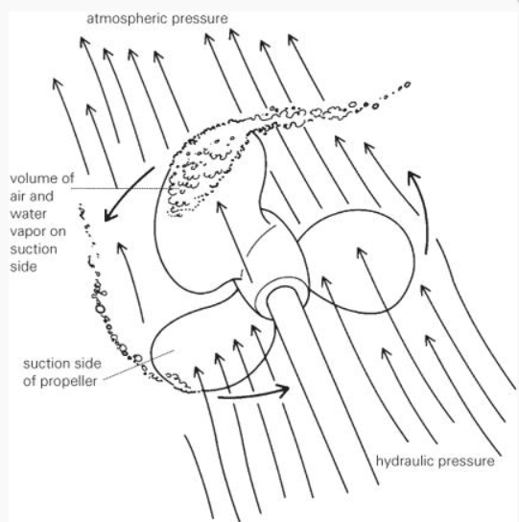

Figure 1 Propeller analysis

## 4.2 Thrust calculation formula

$$T=ρ×n^{2}×D^{5}×K_{T}$$

T=thrust (N).

$ρ$ = liquid density (${Kg}/{m^{3}}$).

n= rotating speed (rpm).

D= diameter (m).

$K_{T}$ =thrust coefiicient.

## 4.3 General thrust formula

$$T=A×ρ×V^{2}$$

T=thrust (N).

A= channel area ($m^{2}$).

$ρ$ =fluid density (${Kg}/{m^{3}}$).

V=velocity of flow (m/s).

The thrust can be calculated by this formula to calculate the thrust coefficient of the propeller at a certain forward speed (advance ratio).

# 5.Power loss in gear

As this is the simulation of boat propulsion system, the power loss in gearbox only involve load gear situation. The no-load power loss is out of our boundary.

$$P_{VZP}=F_{R}×V_{rel}$$

$P_{VZP}=$ load gear losses (kW).

$F_{R}=$ friction force (kN).

$V_{rel}=$ relative velocity (m/s).

The local friction force in the gear mesh can be calculated from the local normal force and the local coefficient of friction along the path of contact.

$$P_{VZP}=F_{N}×{μ×V}_{g}$$

$F_{N}=$ normal force (kN).

$μ$ = friction coefficient (-).

$V_{g}=$ sliding velocity (m/s).

As some parameters are difficult to measure, we further refine the formula.

$H_{v}$ is only depend on geometrical gear data.

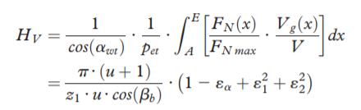

$H_{v}=$ gear loss factor (-).

$μ=$ gear ratio z2/z1 (-).

$Z_{1}=$ number of teeth on the pinion (-).

$β_{b}=$ helix angle at base cylinder ($°$).

$ε_{α}=$ profile contact ratio (-).

$ε_{1,2}=$ tip contact ratio, pinion and gear (-).

The load gear losses can then be simplified as:

$$P_{VZP}=P_{a}×μ_{mz}×H_{v}$$

$P_{a}=$ transmitted power (KW).

$$μ_{mz}= average coefficient of gear friction (-).$$

$H_{v}=$ gear loss factor (-)

When the gear contact points are concentrated near the pitch point because there is no sliding so that low energy loss can be achieved.

The following table lists the parameter comparison between standard gears and low energy loss gears.

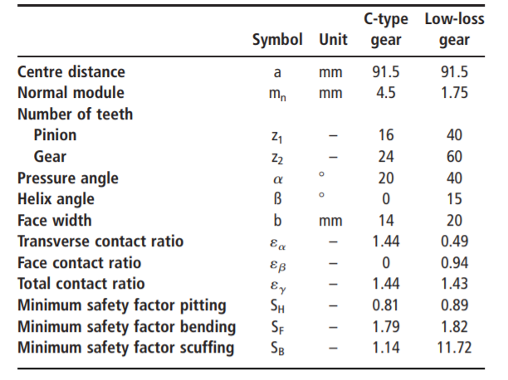

Figure 2 Comparative data of standard and low-loss gears

(Klaus Michaelis, 2011)

# 6.Power loss in gear mesh

The friction coefficient $μ_{M}$ in a gear mesh consists of a portion of solid body friction $μ_{F}$ and a portion of fluid film friction $μ_{EHD}$:

$$μ_{M}=\left(1-ξ\right)× μ_{F}+ξ×μ_{EHD}$$

$μ_{M}=$ mixed friction coefficient (-).

$μ_{F} =$ solid friction coefficient (-).

$μ_{EHD}=$ fluid friction coefficient (-).

$ξ=$ portion of fluid friction (-).

The portion $ξ$ of fluid and solid friction depends on the relative film thickness $λ$ in the contact.

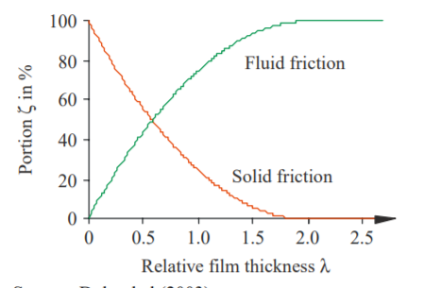

Figure 3 Fluid and solid friction in an EHD contact

The solid friction coefficient and the fluid friction coefficient can be calculated according formula with the parameters for the lubricant from the FZG-FVA efficiency.

$$μ_{F}=μ_{F,R}×{(\frac{P_{H}}{P_{R}})}^{αF}×{(\frac{V_{∑}}{V_{F,R}})}^{βF}$$

$$μ_{F}= solid friction coefficient (-).$$

$μ_{F,R}=$ solid friction coefficient, reference value from test (-).

$P_{H}=$ contact pressure (N/ $mm^{2}$).

$$P_{R}= reference value of contact pressure, 1,000 N/mm2 (-).$$

$V_{∑}=$ sum velocity (m/s).

$V_{F,R}=$ reference value of speed for solid friction, 0.2 m/s (m/s).

$$αF= pressure exponent for solid friction from test (-).$$

$βF$ = speed exponent for solid friction from test (-).

$$μ_{EHD}=μ_{EHD,R}×{(\frac{P_{H}}{P_{R}})}^{αEHD}×{(\frac{V_{∑}}{V_{R,EHD}})}^{βEHD}×{(\frac{η_{oil}}{η_{R}})}^{γEHD}$$

$$μ_{EHD}= fluid friction coefficient (-).$$

$$μ_{EHD,R}= fluid friction coefficient, reference value from test \left(-\right).$$

$P_{H}=$ contact pressure (N/ $mm^{2}$).

$$P_{R}= reference value of contact pressure, 1,000 N/mm2 (N/mm^{2} ).$$

$V_{∑}=$ sum velocity (m/s).

$$V_{R,EHD}= reference value of speed for fluid friction V_{R,F}=8.3 m/s (m/s).$$

$$αEHD= pressure exponent for fluid friction from test (-).$$

$βEHD=$ speed exponent for fluid friction from test (-).

$γEHD$ = viscosity exponent for fluid friction from test (-).

The following table lists the parameters of three common lubricants on the market. (Klaus Michaelis, 2011)

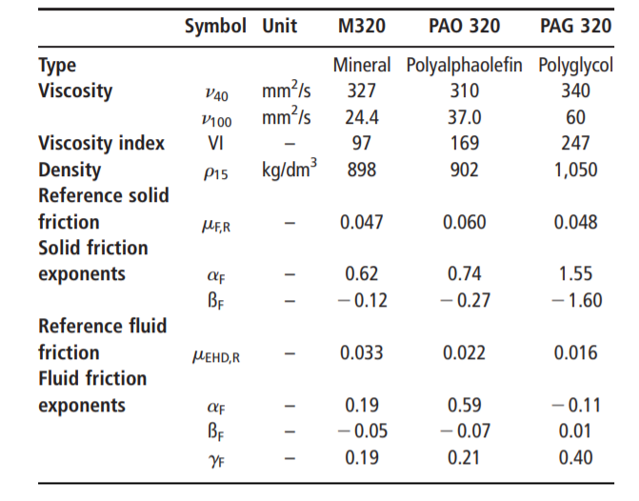

Figure 4 I Lubricant data

# 7.Pwer loss in bearing

There are four sources of bearing friction.

$$M=M_{rr}+M_{sl}+M_{seal}+M_{drag}$$

$M_{rr}$ = the rolling frictional moment and includes effects of lubricant starvation and inlet shear heating (Nmm).

$M_{sl}$ = the sliding frictional moment and includes the effects of the quality of lubrication conditions (Nmm).

$M_{seal}$ = the frictional moment from integral seals [Nmm]

Where bearings are fitted with contact seals, the frictional losses from the seals may exceed those generated in the bearing.

$M_{drag}$ = the frictional moment from drag losses, churning, splashing, etc., in an oil bath [Nmm]

When the total frictional moment, M, of the bearing is known, you can calculate the bearing frictional power loss using.

$$P_{loss}=1.05×{10}^{-4}×M×n$$

$P_{loss}$ = power loss (W).

M = total frictional moment (Nmm).

n = rotational speed (rpm).

(Bearing friction, power loss and starting torque).

# 8.Power loss in shaft

The power loss on the shaft mainly comes from the friction caused by the relative sliding of the bearings and gears. There is no formula to calculate this loss. Due to the presence of lubricant, these friction losses can be ignored.

## 8.1 Shaft efficiency

The shaft efficiency mainly depends on the installation and lubrication of bearings and gears. The shaft efficiency is equal to the ratio of the power obtained by the propeller to the power transmitted by the engine. The shaft efficiency is usually 0.99 but will fluctuate between 0.96-0.995. (Propeller propulsion efficiency, 2017)

# Reference

Bearing friction, power loss and starting torque. (none date). source: SKF: https://www.skf.com/group/products/rolling-bearings/principles-of-rolling-bearing-selection/bearing-selection-process/operating-temperature-and-speed/bearing-friction-power-loss-and-starting-torque

Klaus MichaelisHo¨hn and Michael HinterstoißerBernd-Robert. (2011). Influence factors on gearbox power loss. source: Emerald Insight: https://mediatum.ub.tum.de/doc/1323611/file.pdf

MaritimeUniveristyDaLian. (unknown). source: http://www.docin.com/p-623173267.html

Propeller propulsion efficiency. (2017). source: http://www.360doc.com/content/17/0709/15/12968706_670061103.shtml

TechetA.H. (2016). Marine Propellers . source: Hydrodynamics : https://web.mit.edu/2.016/www/handouts/2005Reading10.pdf

UniversityMaritimeDalian. (none date). Open water test. source: https://wenku.baidu.com/view/c420acba0722192e4536f6d0.html

yuguoPei. (none date). Ship model performance experiment. source: baidu wenku: https://wenku.baidu.com/view/c420acba0722192e4536f6d0.html